Dragon Character Record
Player Name ~
Character Name ~
Profession ~ |  |  |  |  |  |  |  |  |  | Age ~ |  |  | Sex ~
Length ~ |  |  | Flame ~ |  |  | Thick Scales ~ |  | Tough ~ |  |  | Fearsome ~
Body ~ |  |  |  | Skills
Mind ~
Soul ~
Magic ~
Bonus pt. ~
Wounds
Bruise |  |  |  | Equipment:
Flesh wound
Injury
Injury
Injury
Injury
Critical
Critical
Weapons |  |  |  |  |  |  | Multiple? |  | Effect | A |  | B |  | C
Front claws x2 (Effect B+1 M, B-1 F) |  |  |  |  |  |  | 2 |  |  | F |  | I |  | C
Rear claws x2 (Effect B+2) |  |  |  |  |  |  | No |  |  | F |  | I |  | C/K
Bite (Effect B+2) |  |  |  |  |  |  | No |  |  | F |  | I |  | C/K
Constrict (Effect B+1) |  |  |  |  |  |  | No |  |  | I |  | I |  | C
Tail Strike (Effect B/2) |  |  |  |  |  |  | No |  |  | F |  | I |  | I+KO
Flame (Radius Body/5 ft., Effect B/2) |  |  |  |  |  |  | Area |  |  | I |  | I |  | K
Armour = Body / 5 + Scales |  |  |  |  |  |  | - |  |  | - |  | - |  | -
Notes  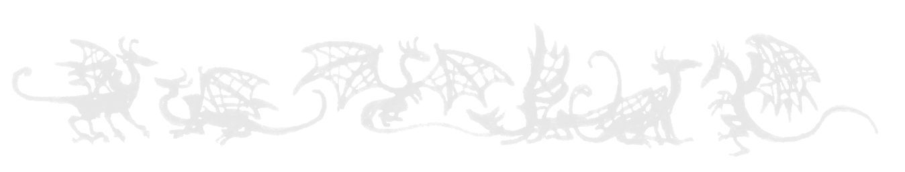 |  |  |  |  |  |  |  |  |  | Portrait
~ This record is provided for personal use only. It may be copied freely, but must not be sold ~

